**VISVESVARAYA TECHNOLOGICAL UNIVERSITY**

**Belagavi, Karnataka-590018**



***A Mini Project Report***

***On***

**“Title of the DBMSMini Project”**

*Submitted in partial fulfillmentfor the award of the Degree of*

**Bachelor of Engineering**

**In**

**Information Science and Engineering**

Submitted by

**SANJAY HC(1VI18IS093)**

**PAVAN HP(1VI18IS066)**



**DEPARTMENT OF INFORMATION SCIENCE ANDENGINEERING**

**VEMANA INSTITUTE OF TECHNOLOGY**

**(Affiliated to VTU and approved by AICTE)**

**#1, Mahayogi Vemana road, Koramangala, Bengaluru-560034**

2020-2021

KarnatakaReddyjanaSangha

**DEPARTMENT OF INFORMATION SCIENCEAND ENGINEERING**

**CERTIFICATE**

This is to certify that **SANJAY HC & PAVAN HP**, bearing**1VI18IS093 & 1VI18IS066,** student of 5th semester, Information Science and Engineering has completed the DBMS Mini Project entitled **“BLOOD BANK MANAGEMENT SYSTEM”** in partial fulfillment for the requirement of the award of degree of **Bachelor of Engineering** in **Information Science and Engineering** of the **Visvesvaraya Technological University, Belagavi** during the academic year 2020-2021. The mini project report has been approved as it satisfies the academic requirements in respect of the mini project work prescribed for the said degree.

Guide HoD Principal

**(Prof. J.Ruby Dinakar**) **(Prof. Rajanna M ) (Dr.Vijayasimha Reddy B.G)**

**External Viva**

Nameofthe Examiner Signaturewith date

1.

2.

**ACKNOWLEDGEMENT**

I sincerely thank Visvesvaraya Technology University for providing a platform to do the internship work.

I express my sincere thanks to **Dr. Vijayasimha Reddy B G**, Principal, Vemana Institute of Technology, Bengaluru, for providing necessary facilities and motivation to carry out DBMS mini project successfully.

I express heartfelt gratitude and humble thanks to **Prof. Rajanna M**, HoD,ISE, Vemana Institute of Technology, for his constant encouragement, inspiration and help to carry out DBMS mini project successfully.

Ithank**Prof.J.Ruby Dinakar**,Assistant Professor, theDBMS Labmini project coordinator for her boundless cooperation and support during the entire process.

Iam thankful to all the teaching and non-teaching staff members of Information Science and Engineering Department for their help and needed support rendered throughout the project work.

SANJAY HC (1VI18IS093)

PAVAN HP(1VI18IS066)

**ABSTRACT**

Despite increasing requirements for blood, only about 5% of the Indian population donates blood. In this website we propose a new and efficient way to overcome such scenarios with our project. These records contains the information like Donor Name, Blood Group, Email Address, etc. After that your contact details will appear in alphabetical order on the screen; the urgent time of a blood requirement, you can quickly check for contacts matching a particular or related blood group and reach out to them through the Blood Bank Website. Blood Bank Management System provides list of donors in your city/area. Use this app in case of emergency. Since almost everyone carries a mobile phone with him/her ,it ensures instant location tracking and communication. The location-based app, operational on android platform, will help users easily find donors of matching blood groups in their location and access their mobile numbers for instant help

## Chapter 1

**INTRODUCTION**

## Every year our nation requires about 4 Cr. units of blood, out of which only 5 Lakh units of blood are available. It is not that, people do not want to donate blood. Often they are unaware of the need and also they do not have a proper facility to enquire about it. As a result, needy people end up going through a lot of pain. India has many blood banks, all-functioning in a decentralized fashion. In the current system, individual hospitals have their own blood banks and there is no interaction between blood banks. The management is ad-hoc with no semblance of organization or standard operating procedures. Donors cannot access blood from blood banks other than the bank where they have donated blood. In present system all the blood banks are attached to hospitals and there is no stand-alone blood bank. Some hospital has its own systems and limitations. Because of low number of donors and more number of blood banks, the efficiency and quality of blood banks are low, resulting in wastage of blood and blood components.

**PROBLEM STATEMENT**

The main aim of the project is to effectively manage the blood banking system. This project enables the users to access nearest blood bank with GPS, it also checks the availability of the required blood group, provides necessary information about the volunteer blood donors who have registered by installing the application.

* The project blood bank management system is known to be a pilot project that is designed for the blood bank to gather blood from various sources and distribute it to the needy people who have high requirements for it.
* The software is designed to handle the daily transactions of the blood bank and search the details when required.

## Chapter 2

**LITERATURE SURVEY**

**“Blood Bank Management Information System in India” by Vikas Kulshreshtha and Dr. Sharad Maheshwari [1]**

introduces the review of main features, merits and demerits provided by the existing Webbased Information System for Blood Banks. This study describes the comparison of various existing system and provide some more idea for improving the existing system. “Benefits of Management Information System in Blood Bank” by Vikas Kulshreshtha and Dr. Sharad Maheshwari[2] describes about the benefits of management information system in blood bank. The paper is basically focused on the blood bank management information system. It discusses about the beneficiaries of the blood bank management information system. “Android Blood Bank” by Prof. Snigdha, Pratiksha Lokhande, Siddhi Kasar and Pranita More[3] describes about the android application which timely updates the information regarding donors where the admin accesses the whole information about blood bank management system. The app provides list of blood banks depending upon the user’s location. In “The Optimization of Blood Donor Information and Management System by Technopedia” by P. Priya and V. Saranya [4], they have proposed an efficient and reliable blood donor information and management system based on GIS integrated in android mobile application. The service provided by the proposed system is needed and valuable to health sector where a quality of the blood is considered for the safety of the patient through a systematic process by the blood management system. “A Study on Blood Bank Management System” by A. Clemen Teena, K. Sankar and S. Kannan[5] is an information management system which helps to manage the records of donors and patients at a blood bank. The system will allow the authorized blood bank officer to login using a secret password and easily manage the records of the blood donors and the patients in need of blood. In “MBB: A Life Saving Application” by Narendra Gupta, Ramakant Gawande and Nikhil Thengadi [6], they have proposed the system that will link all donors. The system will help control a blood transfusion service and create a database to hold data on stocks of blood in each area as data on donors in each city. Furthermore, people will be able to see which patients need blood supplies via the application. They will be able to register as donors and thus receive request from their local clients who needs blood to donate blood in cases of need.

### Design

Professions such as engineering and architecture are concerned with design. Starting with a set of specification engineers and architects seek a cost effective and esthetic solutions that satisfies the specifications. Design is an iterative process rarely in the real world is a problem specified such that there is a unique optimal solution. Thus the designer works iteratively.

### User Interfaces

Our interactions with computers has become dominated by a visual paradigm that includes windows, icons, menus, pointing device, such as a mouse. Although we are familiar with the syntax of MySQL, advances in MySQL have made possible other forms of advantages.

### What is MySQL?

MySQL is multithreaded, multi user SQL database management System (DBMS). The basic program run as server providing multiuser access to a number of databases. The project’s source code is available under terms of the GNU General Public Licence, as well as under a variety of property arguments. MySQL is a database. The data in a MySQL is stored in a Database objects called tables. A table is a collection of related data entries and it consists of columns and rows. The databases are useful when storing information categorically.

MySQL is a central components of the LAMP open source web application software stack (and other “AMP” stacks). LAMP is an acronym for Linux, Apache, MySQL, Perl/PHP/ Python. Application that use the MySQL database include TYP03, MODx, Joomla, WordPress, PHPBB, MyBB and Drupal .MySQL is also used in many high profile, large scale web sites, including Google(Though not for the searches).

### MySQL Command Syntax

As you might have observed from the simple program in the previous section, MySQL uses mainly uses six commands in which SELECT is used to retrieve rows selected from one or more tables. FROM refers to the table from which we need to select the attributes. WHERE clause, if given, indicates condition or conditions that rows must satisfy to be selected. where_ condition is expression that

evaluates to true for each row to be selected. This statement selects all rows if there is no where clause. GROUP BY clause used to group the values of the attributes provided that values must be same. HAVING clause is applied nearly last, just before items are sent to the client, with no optimization. If the HAVING clause refers to a column that is ambiguous, warning occurs. ORDER BY clause is used for the purpose of sorting the values of the attributes in a result. If you use GROUP BY ,output rows are sorted according to GROUP BY columns as if you had an ORDER BY for the same columns.

### MySQL-related Libraries

The MySQL PHP extensions are lightweight wrappes on top of a C client library.The extensions can either use the mysql and library or libmysqlclient library. Choosing a library is a compile time decision. The mysqland library is part of the PHP distribution since 5.3.0. It offers features like lazy connections and query caching, features that are not available with the libmysqlclient, so using the built in library is highly recommended. It is recommended to use the mysqland library instead of the mysql client server. Both libraries are supported and constantly being improved.

## Triggers:

A database trigger is procedural code that is automatically executed in response to certain events on a particular table or view in a database. The trigger is mostly used for maintaining the integrity of the information on the database. For example, when a new record (representing a new worker) is added to the employees table, new records should also be created in the tables of the taxes, vacations and salaries. Triggers can also be used to log historical data.

## Chapter 3

**ANALYSIS & REQUIREMENT SPECIFICATION**

**Purpose**

The purpose of the blood bank management system is to simplify and automate the process of searching for blood in case of emergency and maintain the records of blood donors, recipients, blood donation programs and blood stocks in the bank.

## Scope

The purpose of the blood bank management system is to simplify and automate the process of searching for blood in case of emergency and maintain the records of blood donors, recipients, blood donation programs and blood stocks in the bank.

**HARDWARE AND SOFTWARE REQUIREMENTS**

**HARDWARE REQUIREMENT**

Processor : Intel Core Duo 2.0 GHz or more

RAM : 1 GB or More

Hard disk : 80GB or more

Monitor : 15” CRT, or LCD monitor

Keyboard : Normal or Multimedia

Mouse : Compatible mouse

**SOFTWARE REQUIREMENT**

Front End : PHP

Back End : MYSQL Server

Operation System : Windows 7, 8, 9, 10, XP

## A)Stakeholders

1. System Owner: The Blood Bank
2. System Users:

* Administrators: has full privilege on the system’s functions
* Staffs of Blood Bank: has privilege on the system’s functions has assigned by the administrator
* Public: can view the blood donation events and donate or can make requests for donation (Donor and Recipients full under this category)

B) Data

1. Data about Donor and recipients

**\*** Donor Recipient Id

**\*** Name

**\*** Date of birth

**\*** Sex

**\*** Blood group

**\*** Address

**\*** Contact Number

**\*** Email Address

**\*** Diseases (if any)

**\*** Blood Id

**\*** Event Id

2. Donation program

**\*** Organizer

**\*** Event Id

**\*** Date of donation

**\*** Venue

**\*** Volunteers

**\*** Amount of blood collected

3. Blood

**\*** Blood Id

**\*** Blood Group

**\*** Date of collection

**\*** Expiry date

4.Staff

**\*** Staff Id

**\*** Name

**\*** User Name

**\*** Password

C) Processes

* Login

user The system provides security features through username-password matching where only authorized can access the system with different authorization level.

* Advertisement of blood donation event

This function allows the blood bank staff to publicize the blood donation events online. The public can view the venue and time of the blood donation programs to be held.

*Donor Profile Registration

This allows healthy public to register as volunteer donor.

* Online Request for fresh blood

This allows the probable recipients to make online request to the donor. After the request has been filed donors are matched and the request sent via SMS with necessary details.

* Blood Stock Management

The blood bank staffs can manage the blood stock starting from the blood collection, to blood screening, processing, storage, transference and transfusion through this system. Each process or work flow can be traced from the database. The system will also raise alert to the staff whenever the blood quantity is below its level or when the blood in stock has expired.

* Donor Recipient Management

The records of all donors recipient and their history are kept in one centralized database and thus reducing duplicate data in the database. The record of donation is maintained by the system.

## *Reporting

## The system is able to generate pre-defined reports such as the list of donors, recipients, staffs, the blood quantity in the bank and charts.

## Chapter 4

## ENTITY RELATIONSHIP DIAGRAM

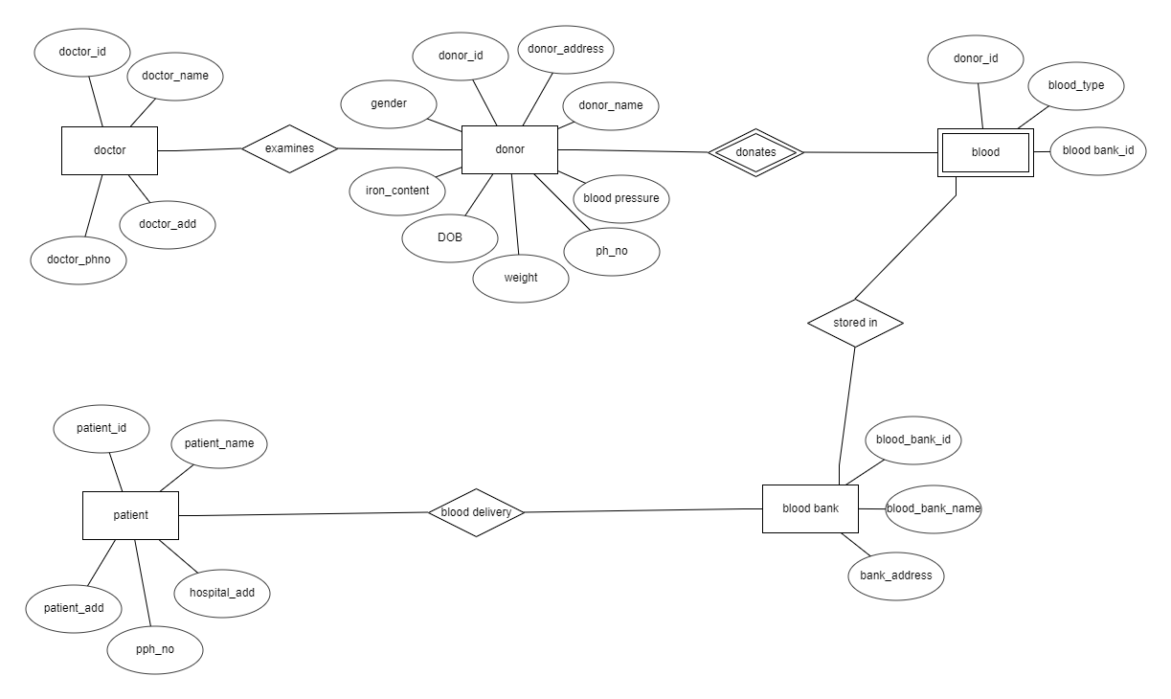

## Chapter 5

**SCHEMA DIAGRAM**

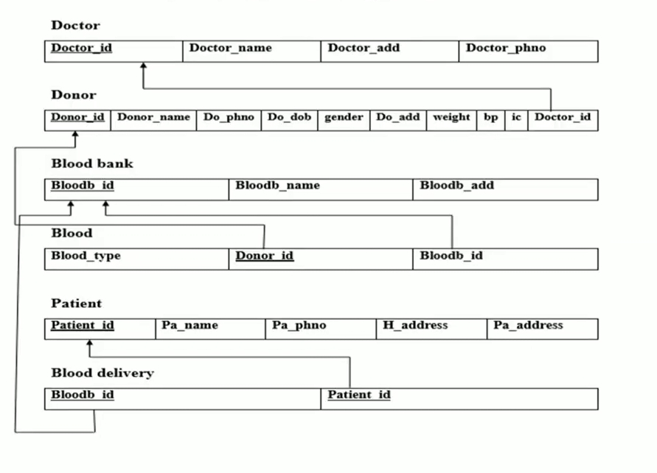

**CONCLUSION**

The website eases the access to the blood of different blood groups required by the particular person in need. The user can know about the nearby blood banks depending on it’s location. The website also tells us about the blood stocks as it is regularly updated by the respective blood banks. The overall basic information which is required for the donor is made available in the website hence making it easy for the user to operate.